Kayla Gallagher

Spring 2022

Data-Driven Journalism

Michelle Minkoff

Google Stories

**Google Trends**

With the threat of war looming, people are searching the key words “Russia” and “Ukraine” at higher rates than usual. In the past 30 days, Google searches of these two countries have spiked.

Russian President Vladimir Putin recently tore up written peace accords with Ukraine and has ordered troops to enter the rebel-held eastern regions of Ukraine, despite his denials of plans to attack the county. However, United States Secretary of State Antony Blinken revealed today that Russia is putting the “final touches” of a full-fledged invasion into Ukraine. President of Ukraine, Volodymr Zelensky, says that Ukraine does not see the need for a war, but if they are attacked, they will defend themselves.

All of the commotion over whether or not the U.S. will involve themselves in the Russia-Ukraine conflict has people doing their research. In a Google Trends search, after Feb. 10, searches of the two countries began a steady increase, until they spiked on Feb. 12, with Russia averaging 58 searches and Ukraine averaging 71. Searches began to decline steadily with some peaks around Feb. 15. As of Monday, Feb. 21, Russia has average 83 Google searches and Ukraine 100.

Washington D.C. showed the largest interest in googling Ukraine, while West Virginia was the state that googled “Russia” the most in the last month. Queries about Ukraine seemed to be more focused towards the conflict with 21 out of 25 queries asking questions about it.

Although the first few searches in the “Russia” category of the Google Trends search are more focused on the 2022 Winter Olympics, 18 out of the 25 relevant queries are about Russia and Ukraine’s relationship. Most of the questions reflect a general confusion over why the two countries are quarreling with each other and when Russia plans to invade, if they do.

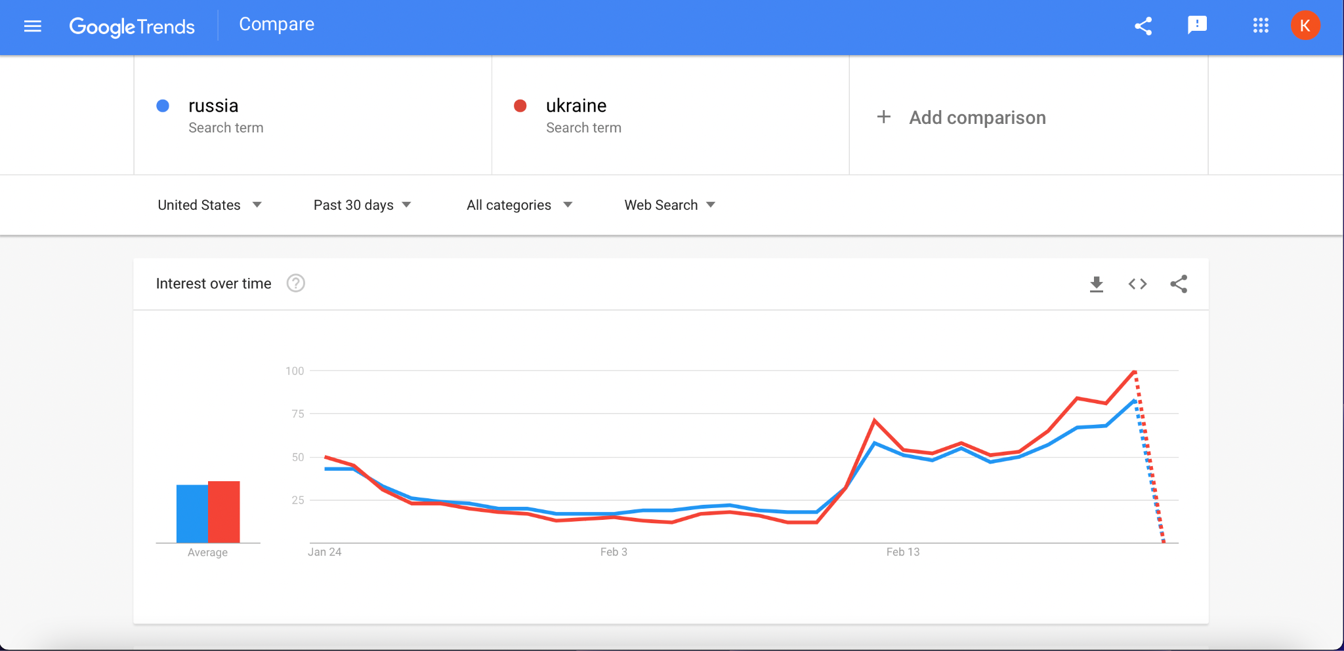

**Google Books**

In 1993, American author Susanna Kaysen turned people’s attention to mental health with her memoir, “Girl, Interrupted.” The story chronicles her experience being diagnosed with borderline personality disorder at a psychiatric hospital in the 1960s. The book grew in popularity when it was adapted into a major motion picture with Hollywood star Winona Ryder starring as Kaysen and Angelina Jolie starring Lisa Rowe, a diagnosed sociopath.

According to the Google Books Ngram Viewer, Winona Ryder, Girl, Interrupted and Susanna Kaysen were all trending book searches, especially in 1999 when the movie adaptation was released. Starting in 1984, Ryder showed a massive increase in searches as she was gaining popularity in the acting world for starring in multiple films like “Beetlejuice” and “Edward Scissorhands.”

Due to the film’s popularity, talk of “Girl, Interrupted” as a film and book began to increase along with Kaysen’s name. The searches of the two don’t reach the same kind of traction that Ryder received, however it seems as though her prevalence contributed to the searches of those words.

In 2000, the film was also nominated for a number of Academy Awards and Critics’ Choice Awards, also contributing to the rise in searches for it on the Internet. Although the movie helped bring attention towards Kaysen’s book, it seems like there was a steady arc of interest in the book and its author over the years before the film adaptation was announced. Then, as the popularity in searches for Ryder decreased, so did the searches for the book and the movie at a similar rate.

